Title:
Name: Primrose Mukwesha
Student number: 2805000491
Date: 20 July 2026

Introduction and Objectives
This project focuses on building a Retail Sales Data Agent using Databricks Genie. The objective was to create data agent that can analyze retail sales data, answer questions and provide useful insights to support decision making. The project involved preparing the dataset, configuring the agent, testing it with business questions and validating the accuracy of its responses.

Data Description
The Retail Sales Dataset contains retail transaction records used for sales analysis.
Column | Description
Transaction ID | Unique identifier for each transaction
Date | Date of purchase
Customer ID | Unique customer identifier
Gender | Customer gender (male or female)
Age | Customer age
Product Category | Group of products purchased
Quantity | Number of items purchased
Price per Unit | Cost of one item
Total Amount | Total sales value for the transaction

Screenshots

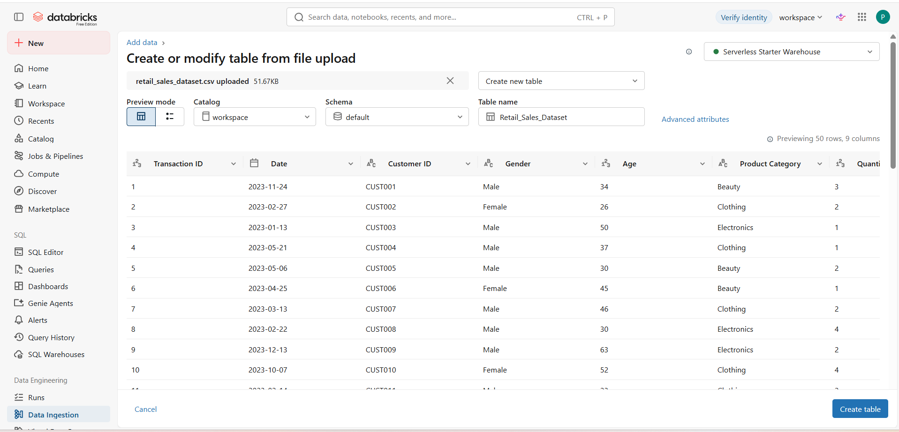
The above image shows dataset upload

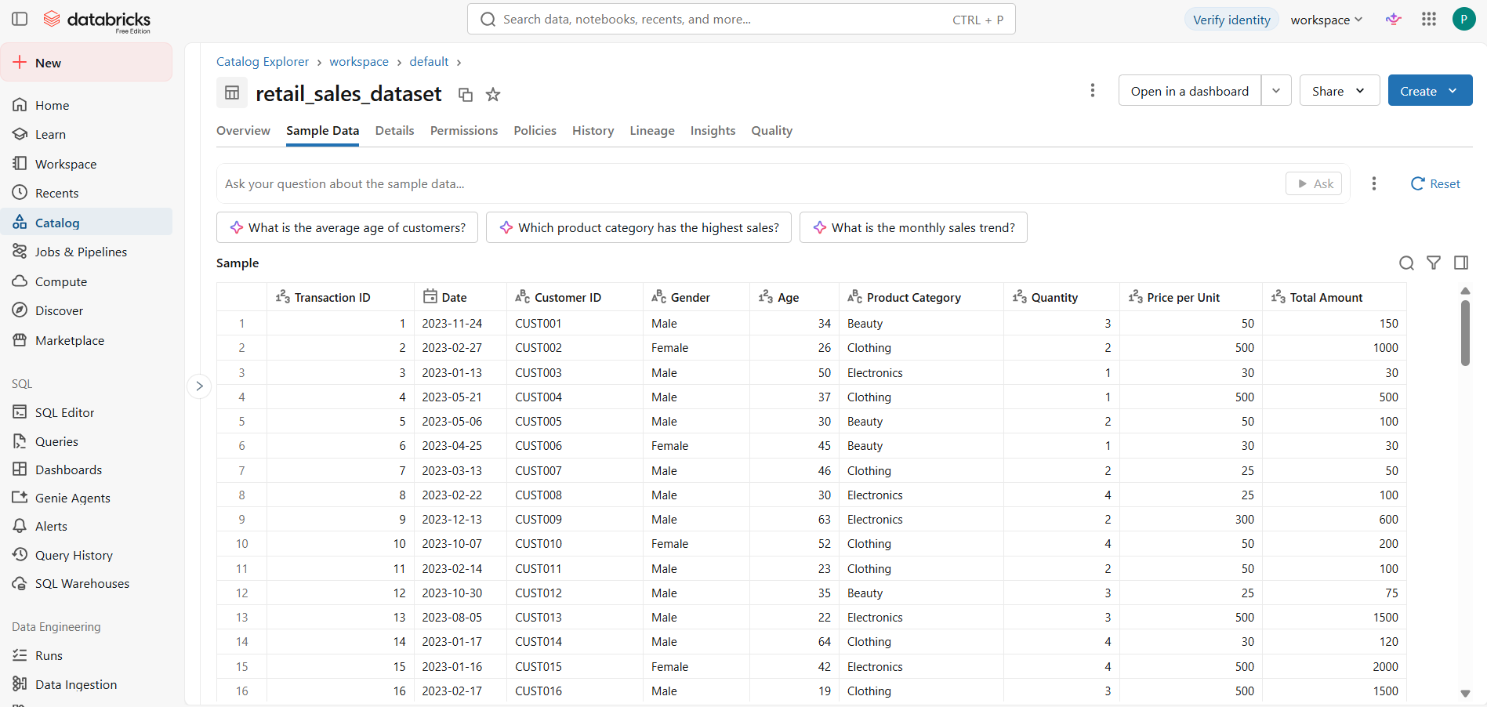
The above image shows dataset review

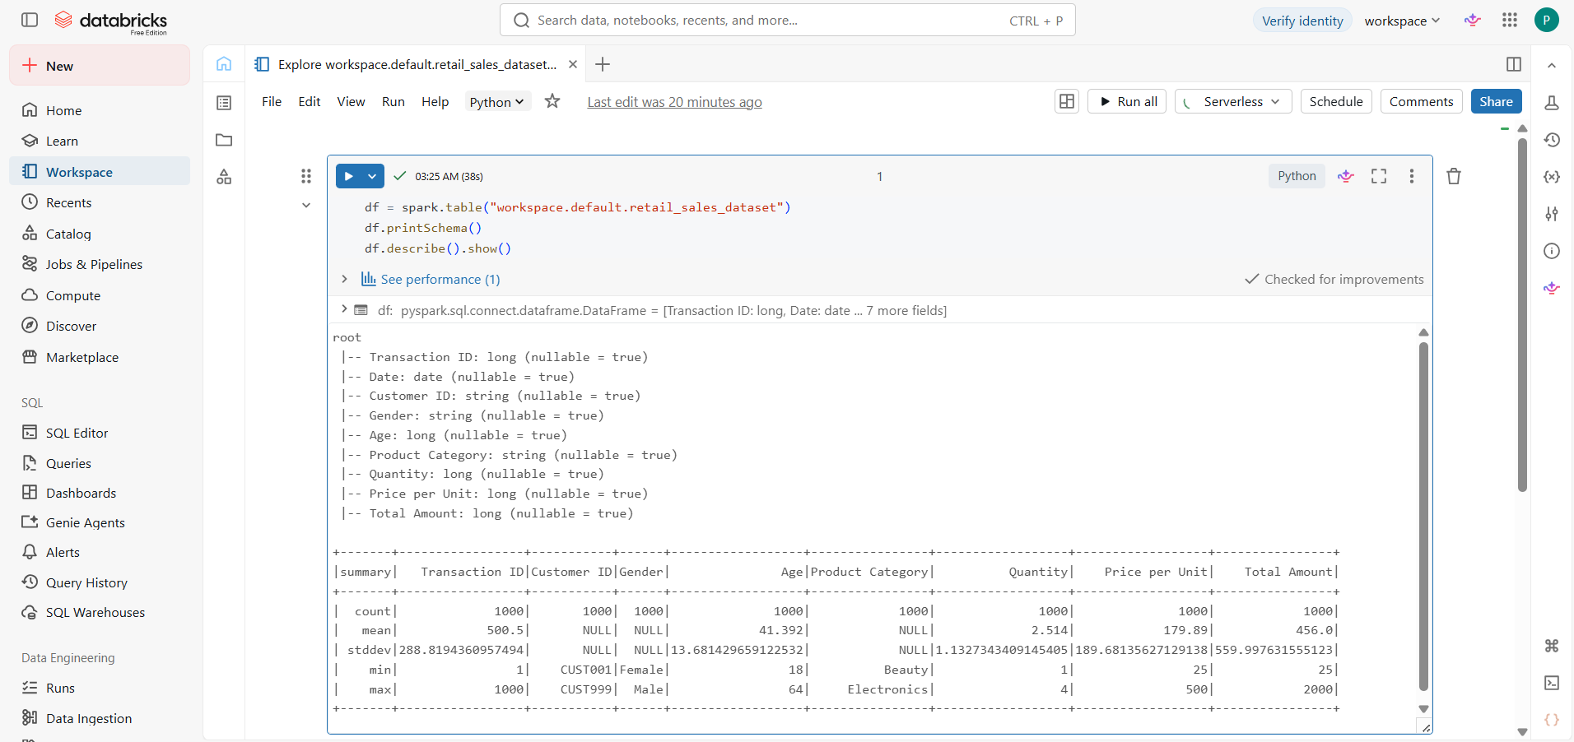
The image above shows table preparation

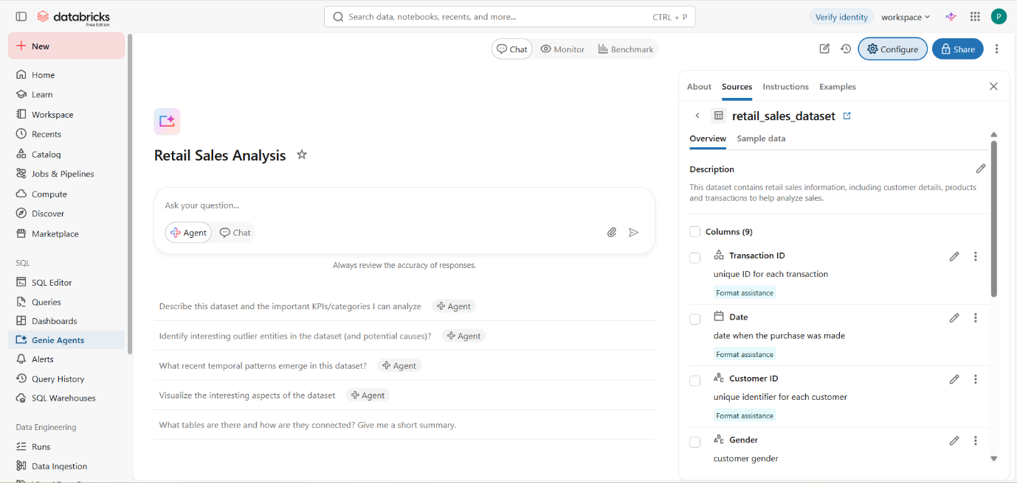
The image above shows Genie Agent setup

Genie Agent Instructions

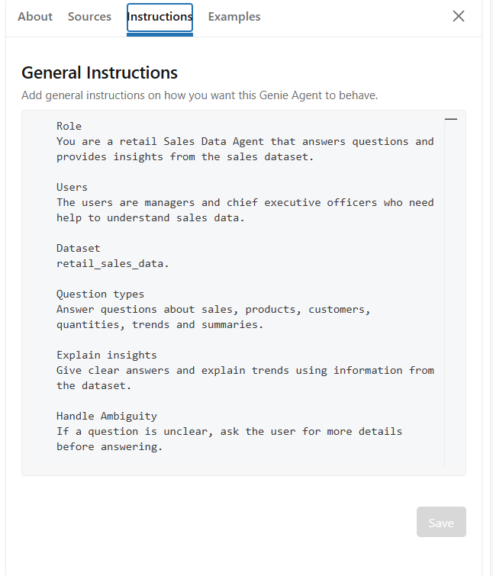

The 10 Questions and Agent Answers

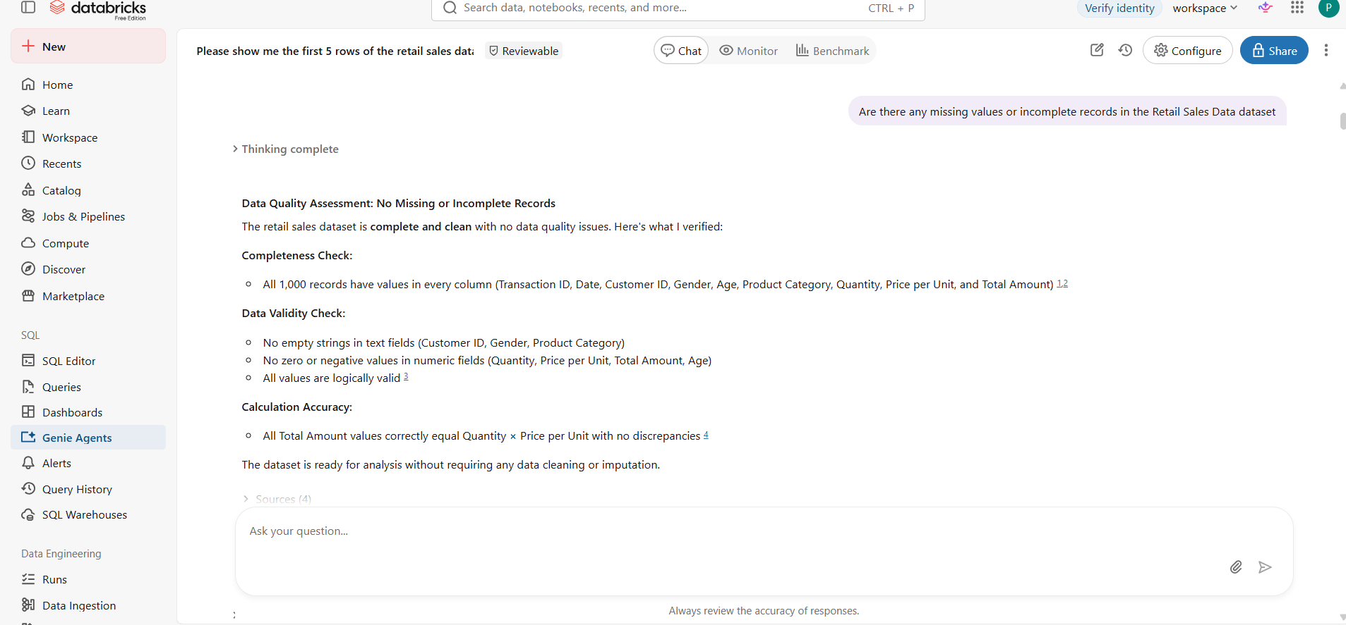
Question 1
Are there any missing values or incomplete records in the dataset?
Agent answer
There are no missing or incomplete records

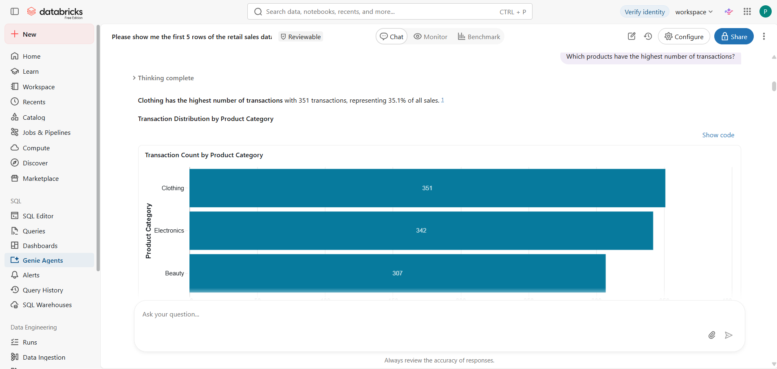
Question 2
Which products have the highest number of transactions?
Agent answer
Clothing has the highest number of transactions with 351 transactions representing 35.1% of all sales.
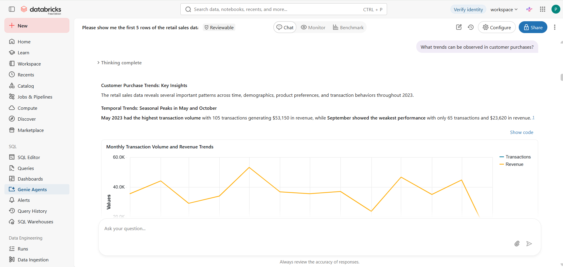
Question 3
What trends can be observed in customer purchase?
Agent answer
The retail sales data reveals several important patterns across time, demographics, product preferences and transaction behaviors throughout 2023.

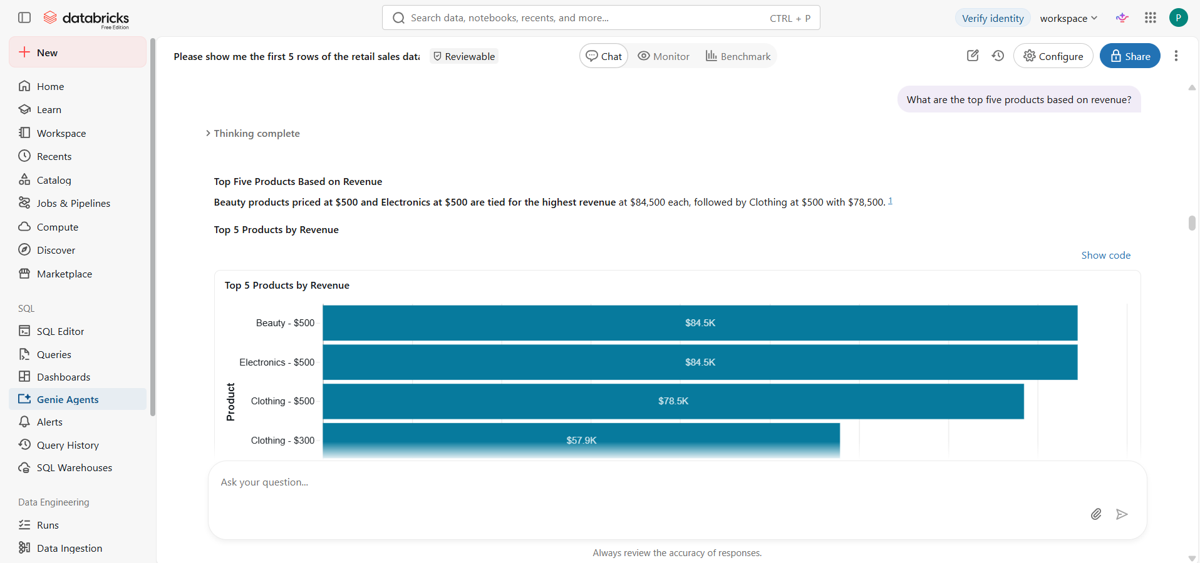
Question 4
What are the top 5 products based on revenue?
Agent answer
Beauty products priced at $500 and Electronics at $500 are tied for the highest revenue at $84,500 each, followed by Clothing at $500 with $78.500.

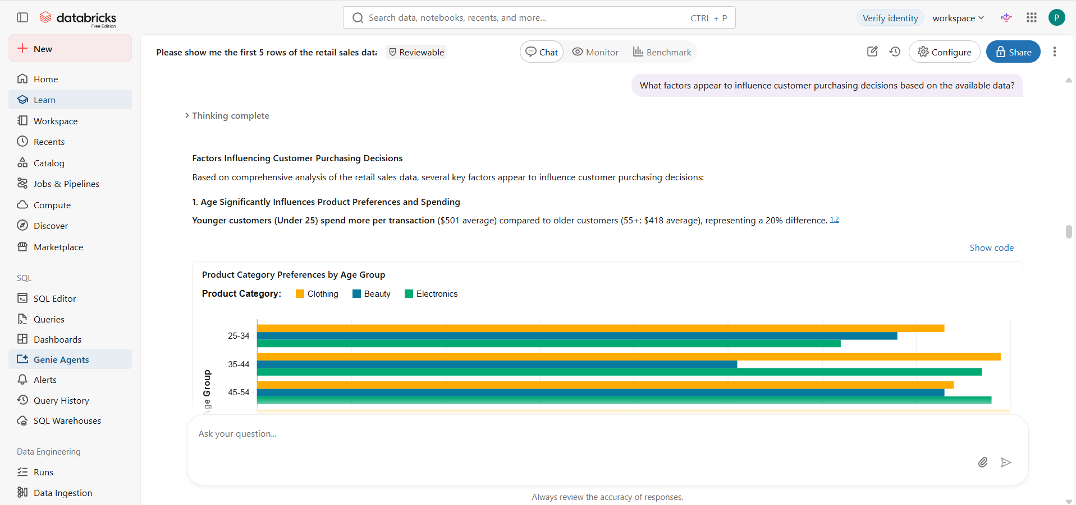
Question 5
What factors appear to influence customer purchasing decisions based on the available data?
Agent answer
Based on comprehensive analysis of the retail sales data, several key factors appear to influence customer purchasing decisions.
Example: Age
Young customers (under 25) spend more per transaction ($501 average) compared to older customers (55+$418 average ), representing a 20% difference.

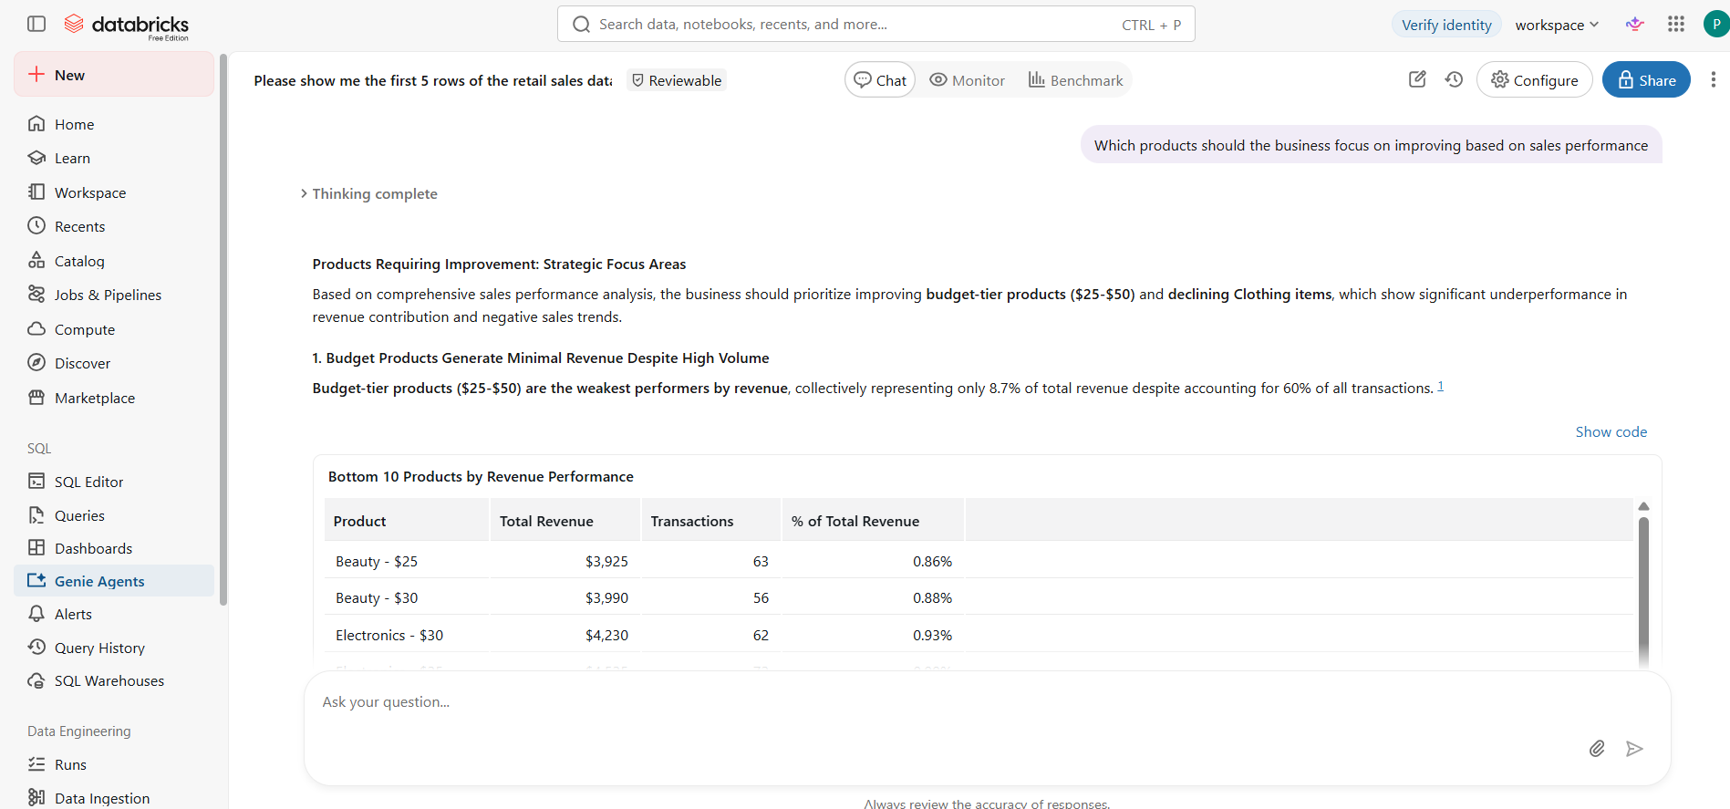

Question 6
Which products should the business focus on improving based on sales performance?
Agent answer
Based on comprehensive sales performance analysis, the business should prioritize improving budget-tier products ($25-$50) and declining Clothing items, which show significant underperformance in revenue contribution and negative sales trends.
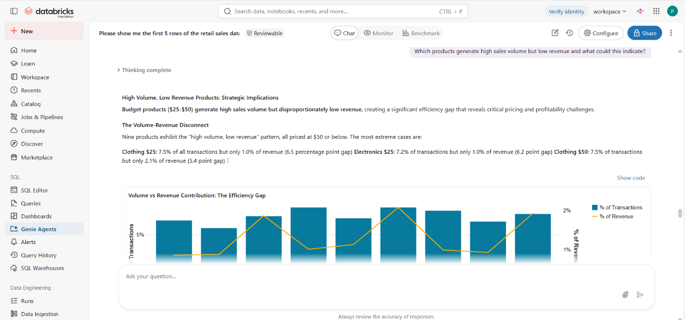

Question 7
Which products generate high sales volume but low revenue and what could that indicate?
Agent answer
Budget products ($25-$50) generate high sales volume but disproportionately low revenue, creating a significant efficiency gap that reveals critical pricing and profitability challenges.

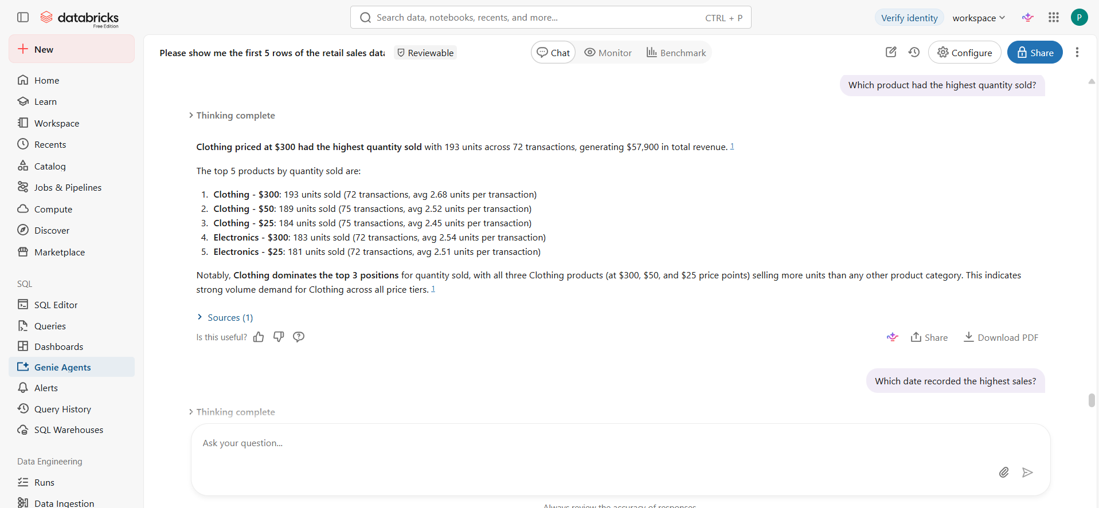
Question 8
Which product had the highest quantity sold?
Agent answer
Clothing priced at $300 was the highest quantity sold with 193 units across 72 transactions, generating $57.900 in total revenue
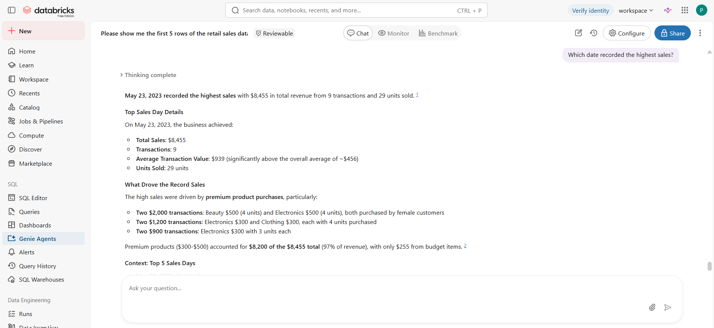

Question 9
Which date recorded the highest sales?
Agent answer
23 May 2023 recorded the highest sales with $8,455 in total revenue from 9 transactions and 29 units sold.

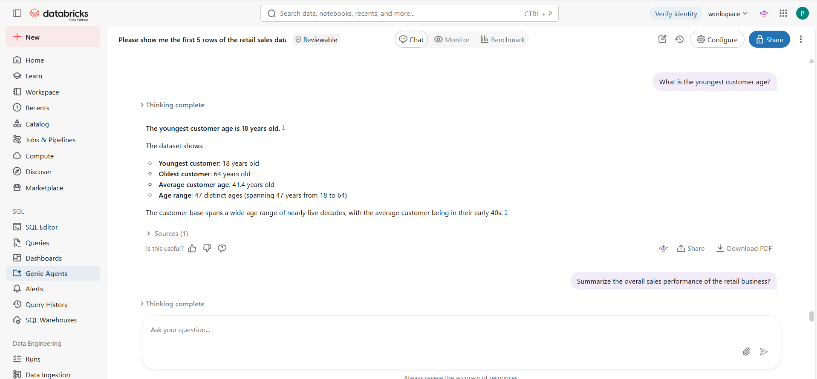

Question 10
What is the youngest customer age?
Agent answer
The youngest customer is 18 years old.
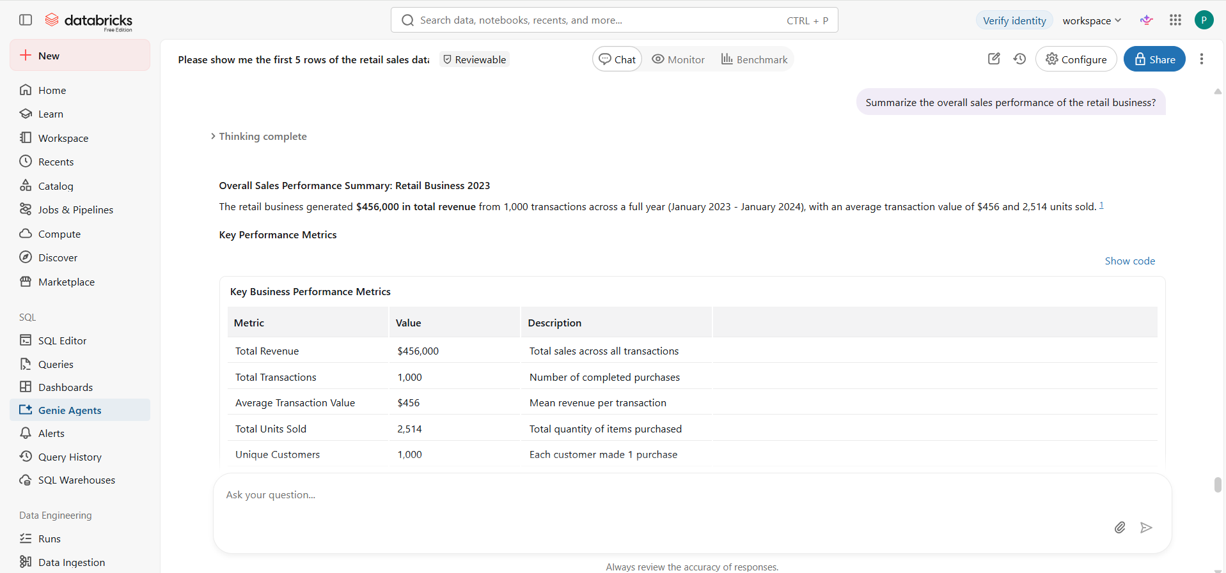

Above shows the summarized sales performance of the retail business.

Validation of 3 Answers

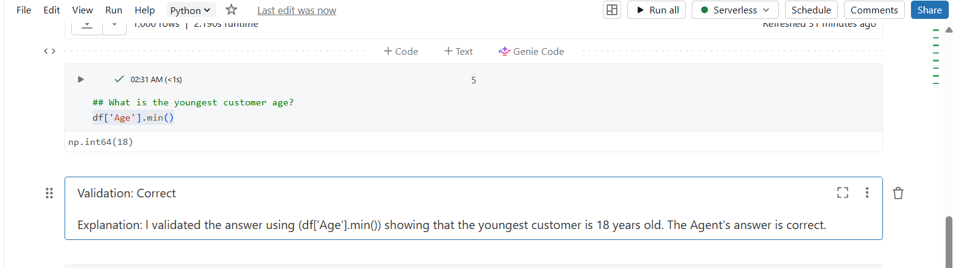

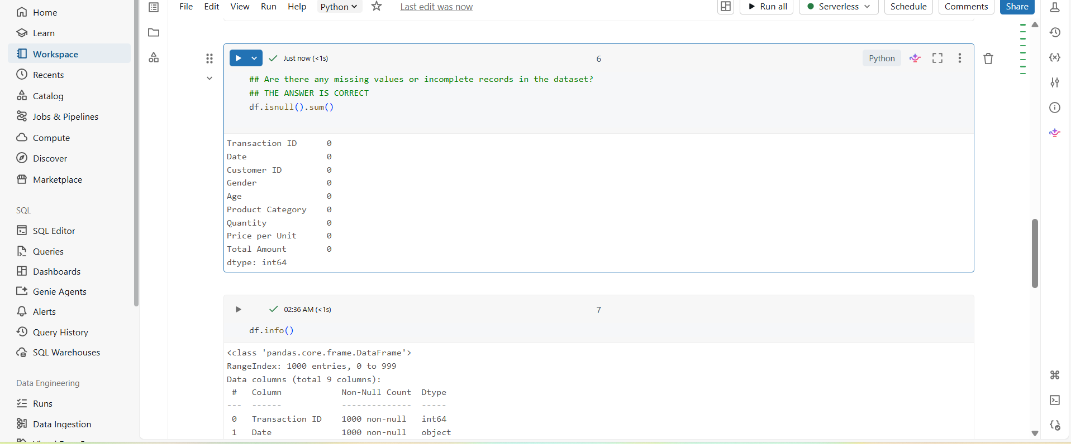
Answer: Partially correct
Explanation: I validated the answer using python and it gives the same answer as genie agent.

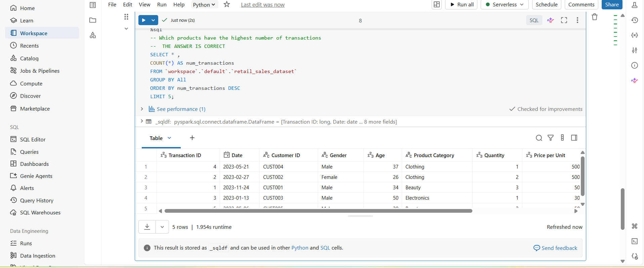

Answer: Partially correct
Explanation: I used SQL to validate the answer, and the outcome proves that genie agent provided the correct answer.
Key Insights
- The analysis showed that Clothing was one of the strongest performing categories based on transaction volume.
- Customer purchasing patterns also showed seasonal changes.
- Age appeared to have an influence on purchasing behavior while gender had less impact.
- Some products generated high sales volumes but relatively lower revenue.

Business Recommendations
- The business should focus on improving lower-performing products and monitoring seasonal demand patterns.
- Use customer age insights to create targeted marketing strategies.
- Products with high sales volume but lower revenue should be reviewed for pricing and profitability improvements.

Conclusion
This project successfully demonstrated how a Databricks Genie Agent can be used to analyze retail sales data and answer business questions. The most challenging part was validating the agent’s responses and ensuring the answers matched the dataset. In future, the project could be improved by adding more data sources and creating more advanced analysis.

https://github.com/primmkwesha-hash/Retail-Sales-Data-Agent

